# **Competitive Interactions**

#### *Timo Bron - What are the similarities, differences, and interactions between one team and the other from a competitive point of view?*

***Rocket League***

**Similarities**

* All players have the same core gameplay loop; drive into the ball to move it into the opposing team’s goal.
* Every player has the same abilities.
* Every team is always trying to have the ball in their possession.
* Every team is constantly switching between offense and defense, depending which team has the ball.
* The ball is the main point of focus; nothing is as important as the ball.
* Boost is available to all players on the field.

**Differences**

* One team must score in goal A, the other team in goal B. The gameplay loop is the same, but the goal itself is the exact opposite.
* The only thing that sets players apart is their skill.
* Strategies differ; a team can play offensive or defensive and still have a chance to win the game. The other team will alter their strategy to counter them.
* Players of higher skill levels have mastered certain elements of the game such as mid-air shots. This gives them an advantage over other players.
* A player’s skill is based on their experience in the game, in combination with other skills like spatial awareness and reflexes.
* Each player has a different amount of Boost. Having more Boost than another player can give them a great advantage, both offensive and defensive.

**Interactions**

* The opposing teams interact with each other through the ball, which represents their opposing goals.
* Players physically ram into each other to move them out of the way or to destroy them completely.
* One team’s win condition is also the other team’s losing condition.

**Conclusions**

* Having one shared goal in the game takes away from the difference between defence and offence; both teams share the same goal, and an offensive strategy is the same as a defensive strategy.
* Polar opposite goals can achieve enough of a feeling of competition, where one team’s win condition means the other team’s lose condition.
* When the core gameplay loop is the same, the most important thing that will set players apart is their skill. This is crucial for esports.
* Allowing players to reach a certain skill level where they can perform certain actions (whether a hard or soft lock) will allow them to have a *fair* advantage over other players.
* Rocket League has a Boost mechanic that allows players to have a small, temporary advantage over players that have less Boost. They can adopt this mechanic in their strategy, and the way they use this feature may determine whether they win or lose. This resource is available to all players equally, which makes it more skill based. In our game this resource could be a new feature, or it could actually be the built up speed of the ball.

# 

# **Level Design Research**

#### *Timo Bron - What are the level design genre conventions and standards for 1. Arena versus games; 2. Ball sports games; 3. Skating games?*

#### ***Arena Versus***

*Based on Capture the Flag (CTF) game modes.*

**Introduction**

* This part of the research entry assumes our game will have two seperate goals.
* CTF seems to be partially similar to a ball game; a team has to break through the opposing team’s defenses to reach their base (in our game that would be their side of the field) and steal their flag (score a goal). Bringing the flag back to their own base is not present in our game, so we will focus on the aspect of breaking through another team’s defenses.

**Observations**

* The ideal CTF level should try to enhance the core gameplay and promote the use of complex strategies, which is done by allowing players to choose their own path and approach by creating many different hallways to the objective.[1]
  + Although our level won’t have distinct hallways or clear paths, we can still guide players in certain directions to create the same effect. By using ramps, obstacles, and guiding lines, we can offer different paths to the opposing team’s goal, which can lead directly to the objective or offer a more stealthy approach along the ground or the edges of the level.
* Most, if not all CTF levels in Team Fortress 2 are symmetrical. This seems to be the most effective way to balance a level like this for both parties; each team has a base with identical rooms and hallways leading to those rooms. The only difference is color to identify in which base the player is in. If a CTF level is harder to attack than to defend, it might not play or flow well, but it will not cause imbalance as the other team will have to overcome the same struggle. As long as both sides of the level are identical, both teams will have to deal with the (dis)advantages the level brings them.
  + Having symmetrical level layout is a very safe and effective way of achieving balance. Our main level(s) should have this layout; we can experiment with this later, but for now, symmetry is crucial.

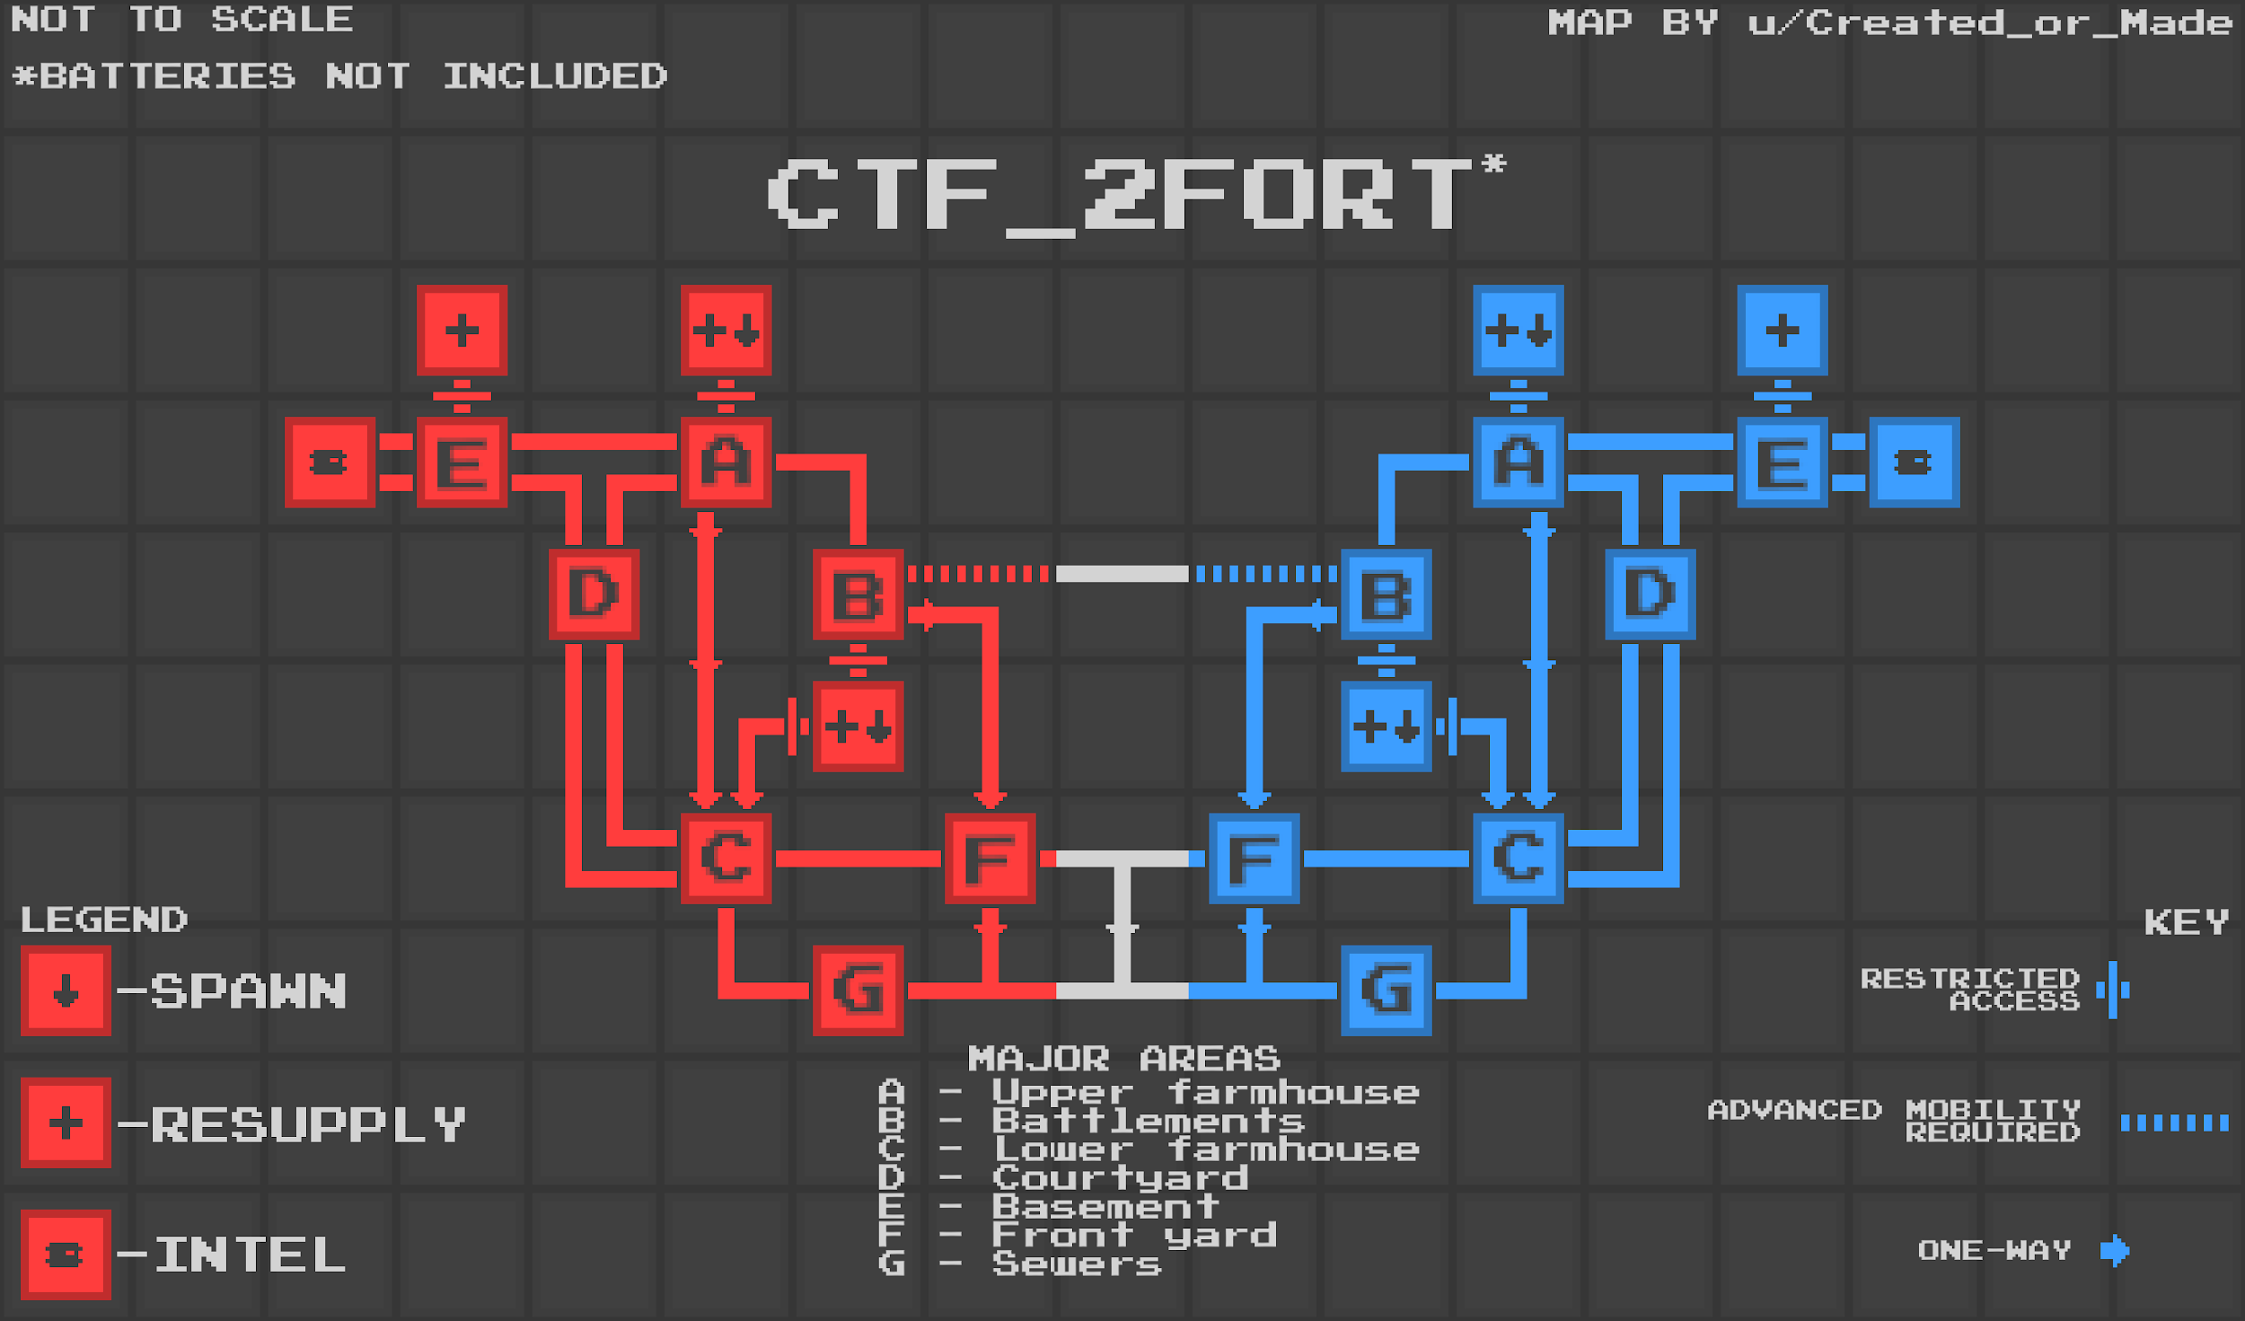

*A node map of one of Team Fortress 2’s most popular - and controversial[2] - levels, ctf_2fort. Made by /u/Created_or_Made (*[*https://www.reddit.com/r/tf2/comments/8nuuaq/i_made_a_map_of_2fort_so_i_can_hopefully/*](https://www.reddit.com/r/tf2/comments/8nuuaq/i_made_a_map_of_2fort_so_i_can_hopefully/)*).*

* The node map above shows several one-way paths. Having one-way paths can offer teams different ways to attack or defend objectives. For example, area B is a one-way path to area F, as area B is above area F and cannot be accessed from there (excluding classes with better mobility). This offers the defending team a better defense, as they have both the advantage of being able to walk different paths, as well as having the high ground. An attacking team only has two paths to choose from; either going to area F or area G. Defending seems to be easier than attacking because of the one-way paths. Classes with better mobility, described on the next page, can usually bypass the restrictions set by the one-way paths; one-way paths should guide players into a certain direction, but not completely be inaccessible.
  + Having one-way paths influences a team’s ability to attack or defend, and can be used to guide players in certain directions. In our game, this is a useful tool to make defending easier for a team, in case rounds are too short because of attacking being too easy, or vice versa.
* In the node map, characters with advanced mobility have a path only they can take. This shows us that having a class with extra mobility has an advantage over other classes, as attacking or defending is easier for them. The level plays into their class abilities and offers them this advantage. Allowing classes with movement abilities to bypass one-way paths is another way of giving them an advantage.
  + If we’re going to have classes with better mobility, we need to make sure the level affords for players using these abilities to gain an advantage.
* Something that all CTF levels in Team Fortress 2 have in common is the presence of multiple vertical layers. Looking at ctf_2fort, there are three vertical layers that influence gameplay.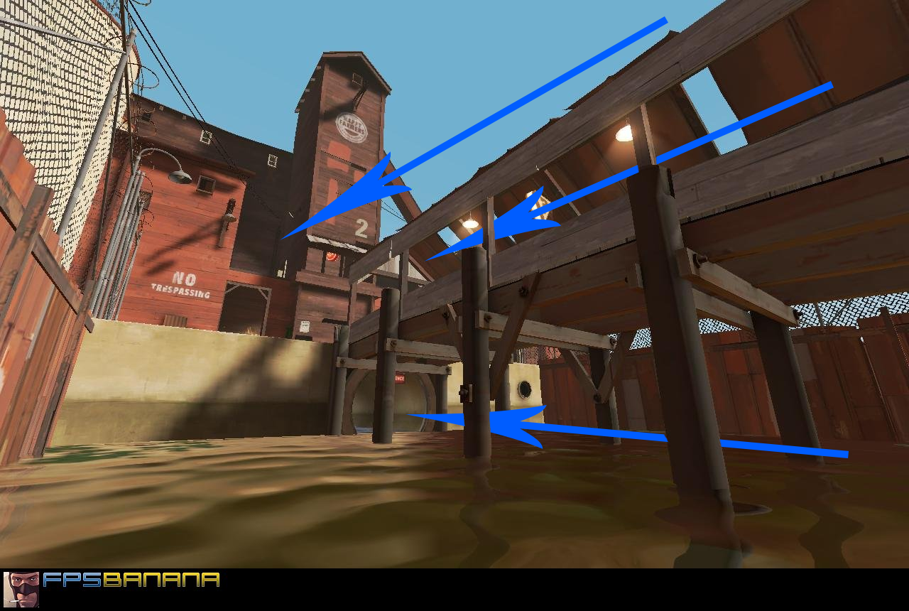The middle layer is the primary play area and is where all of the action happens. The top layer is an area that is above all other layers; this high ground provides players a defensive advantage and could impact what is happening in the lower areas. The bottom layer is an area that has the least amount of tension and provides players with an alternative, more stealthy route; however, they are more vulnerable to attacks from above.
  + Having multiple vertical layers is a given in our game. The middle area is the space where all the passing and combat happens, the top area would feature platforms where the player can get an overview of the level, and the bottom area where the player can either get more momentum to get back up to the middle area, or sneak past an enemy team’s defence.

**Conclusions**

* Most CTF levels are symmetrical to keep balance. The first level(s) of our game should be symmetrical as this is the safest and most effective way to achieve balance.
* Guiding players to follow a certain path creates (dis)advantages of defending/attacking. This can be achieved by having multiple paths leading towards an objective, by restricting some paths to only one direction or certain classes with better mobility, or by using primary/secondary routes. These (dis)advantages are what creates strategy, makes attack/defense more of a struggle between two teams, and makes sure matches don’t end too soon.
* Having extra mobility allows certain classes to bypass restrictions set in the level. The level should play into these abilities to give those classes a certain advantage.
* All levels for our games should have three vertical layers; a middle area which is the primary playing field where the action happens, a top area that features platforms where the player can escape the action and get an overview of the match, and a bottom area that affords for gaining more momentum to get back up into the fight, or for more stealthy but vulnerable routes.

#### ***Ball Sports***

*Based on Rocket League.*

**Introduction**

* Rocket League’s default level at first glance seems to be very bland; it’s a large open field with no obstacles in it. I want to know why the level plays nicely, as well as take a look at the “experimental” levels Rocket League features.
* Rocket League is taken as example because of its similar arena-based ball sports gameplay that emphasizes player movement.

**Observations**

* The level features a large, open field with no obstacles, and with boost pickups placed throughout the stage. The image below is a top down view, with booster pads marked.
* The biggest boost pads are placed at the corners and sides of the level. Players tend to go here to collect the most boost as fast as possible. The boost pads in the middle are line up circularly around the centre.[3]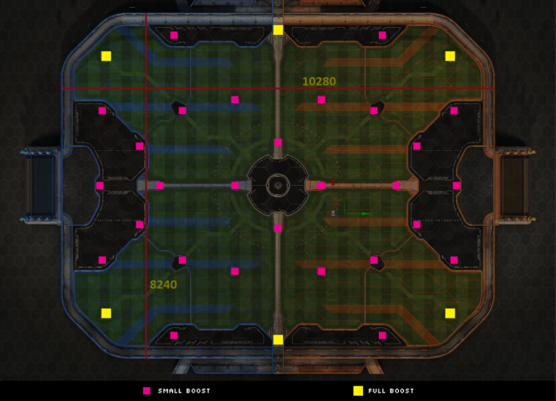
* Boost pads in this game seem as if they encourage the player to drive *around* the centre of the map, not straight through it. The level appears to flow around the centre, with the edges of the level being the most interesting.
* There are no sharp corners anywhere in the level; the corners of the map are rounded, and wall edges on the floor are rounded as well, even allowing players to drive on the walls of the stage.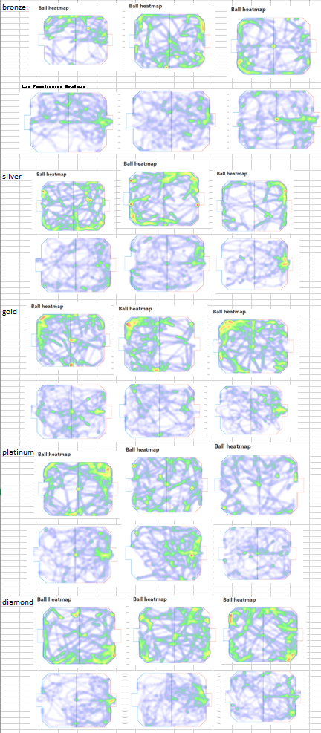
  + This is another indication that players tend to go to the very edges of the stage, as this offers them a way to get up into the air, if the ball flies there. The ball tends to fly towards the sides and corners of the level, like the heat map shows. The game offers players a way to easily get to the ball in case it lands there.
* In a few experimental stages, the levels play into this flow around the edges. The level below is one where the goals have multiplied, and players must score from the sides, which plays into the way the ball usually ends up near the edges and corners, making it more difficult to defend your goal in this level.

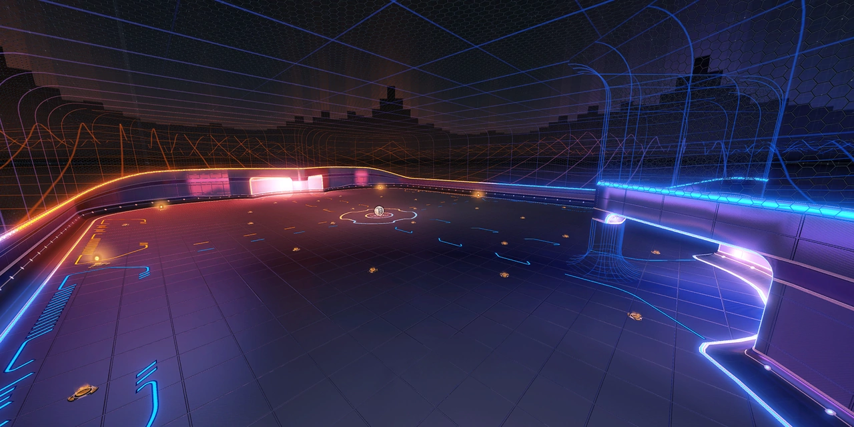

Another stage had been made a circle, with the two goals back-to-back. This emphasized the circular flow of the default level to a point where *everything* became circular.

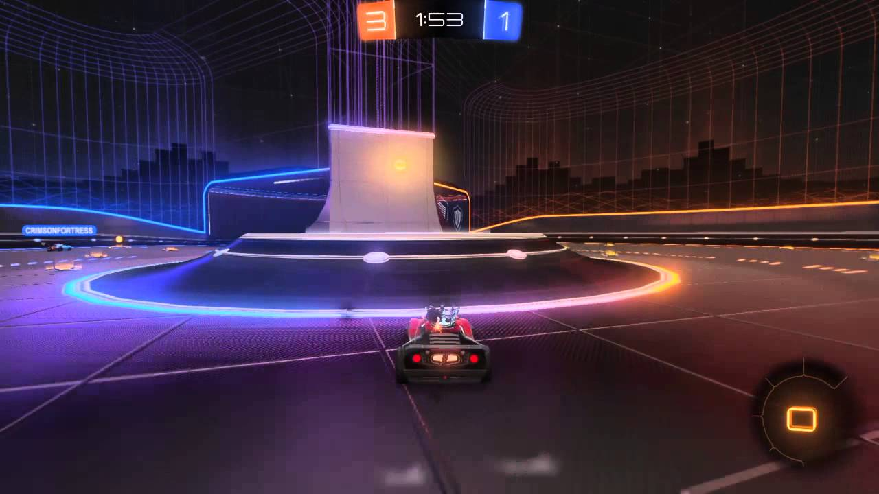

One stage does the exact opposite, raising the two goals slightly, with the middle becoming a bit lower than the two far ends of the stage. The physics of the ball will make it roll back towards the centre, making it harder to score.

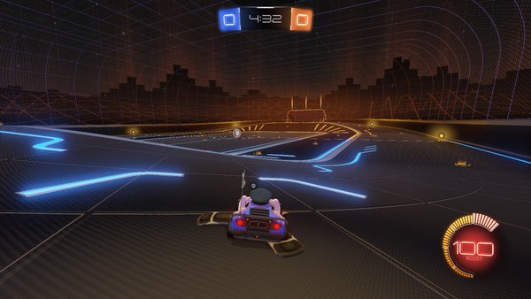

**Conclusions**

* Rocket League encourages players to move towards the edges of the map, as catching the ball is easier here than in the middle of the stage. Especially the corners are places where the ball often lands. In our level, we would have to place more ramps/bowls near the edges and corners of the level, and aim the other ramps towards those spots, to help make catching the ball easier.
* Knowing how the game flows, we can change the layout of a level to emphasize or balance out certain elements. If, for instance, catching the ball is still too hard, we can raise certain spots in the level, or change the general shape of the stage.
* It might be beneficial to allow players to more easily get into the air near the edges of the level, something other than the normal ramps and halfpipes, in case players find it hard to catch balls mid-air.

#### ***Skating***

*Based on Tony Hawk’s Pro Skater 2.*

**Introduction**

* Both our movement and level layout is very similar to skating. It might be useful to analyze level design of a skating game to see how they manage to keep the player flowing smoothly through a level.
* This research entry focuses on Tony Hawk’s Pro Skater 2, a popular entry in a beloved skating game franchise. We’re specifically looking at a 100% speedrun of the game, as these speedrunners are the most familiar with the movement and flow of the game and follow either the intended or fastest way (which is often the same) to complete a level fully.

**Observations**

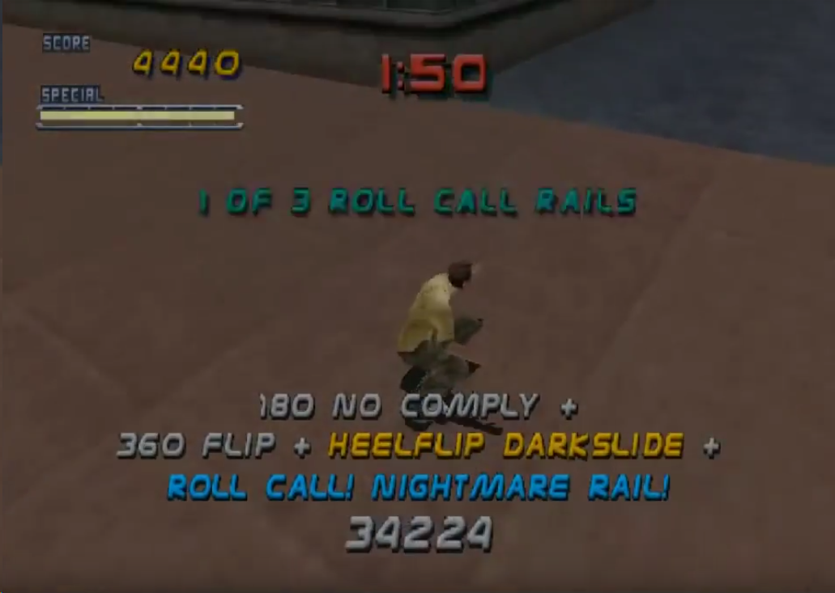

* The player performs tricks on the ground and in the air to earn points, which is one of the primary goals of the game. If the player performs tricks in rapid succession, the points will build up to an even larger amount, in addition to being able to make multiplier combos by doing multiple tricks within one jump. Points are not immediately added up to the actual score meter; only if the player does not do any tricks in a certain timeframe will the points be added up to the score meter. This allows players to build up a large point combo before increasing their actual score and resetting their points.
  + This point/score system encourages players to keep flowing from ramp to ramp to perform tricks in rapid succession. Because earning points is so satisfying (big, colored text on the screen, insanely high numbers, audio feedback) and helps them reach the goals necessary for unlocking new levels, players want to get the biggest score possible and are thus trying to get the highest speed and perform the biggest tricks.
  + While this is not necessarily a level design aspect, it’s still good to keep in mind for our game. We’ve subconsciously done a similar thing, where the points are earned through passing the ball, and the score meter are the goals made and absolute points earned by a team. Involving movement in this could emphasize the necessity of moving fast and high, and give a reason for aerial movement.
* Each level has a set of objectives the player can complete to earn money, which is used to unlock the next stage. These objectives involve collecting a set number of items, destroying marked objects, doing a certain trick at a specific location, and reaching a certain score threshold.
  + Since the level is quite open and the goals shouldn’t take focus away from doing tricks, the collectibles are often placed on ramps, rails, pipes etc. To prevent the objectives from being hard to find, they’re placed in such a way that the player can follow a certain path to collect multiple collectibles without breaking flow. Ramps are often aimed towards each other, so the player can easily go flow through them. It’s not the *finding* that’s important, it’s the *collecting*.
  + On the next page you can see a speedrunner’s first run to complete the goals (he doesn’t complete all of them in one go)[4]. There are only a few instances where they make a sharp turn to go towards another objective. Within the first 22 seconds, they collect four items without having to make any sharp turns; everything flows into each other.
* Geometry-wise, there are a lot of ramps placed up against walls. There’s some minor difference in verticality for readability and flow purposes, as obviously not all ramps should flow into each other.
  + We can use this verticality difference in our game as well to emphasize certain paths or make getting more momentum easier.
  + Placing ramps up against walls goes back to the previous research entry where I concluded that this can improve flow. Not all walls in THPS2 have ramps, because of a mechanic where the player can skate up against walls for a short period of time, which is mainly used to maintain player speed. We don’t have something like that, so having ramps would be useful.

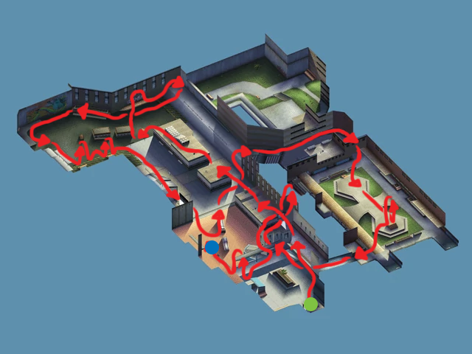

**Conclusions**

* The score system in our game could profit from having a mechanic that incorporates player speed with the score. This could provide a valid reason for having fast-paced aerial movement.
* Because of the importance of speed and momentum, ramps, pipes, etc. should all flow into each other to maintain the player’s speed and flow through the level. Having something that rewards the player for maintaining their speed would tie in nicely with this.
* Differences in verticality helps emphasize paths in a level. It could prevent players from following unintended paths and losing their momentum by doing so. This also improves readability of paths.

1. Matheus Pitillo, *Capture the Flag Level: Metro Interitum,* <http://www.matheuspitillo.com/tt_portfolio/ctf-level/>
2. Ctf_2fort is a controversial level, but mainly due to its level geometry not being suitable for some aspects of Team Fortress 2’s gameplay. Level layout is not an issue, which is why I found ctf_2fort to still be a viable research item.
3. Taken from <https://steamcommunity.com/sharedfiles/filedetails/?id=1279801728>
4. <https://www.youtube.com/watch?v=U35P1UwgKlg>